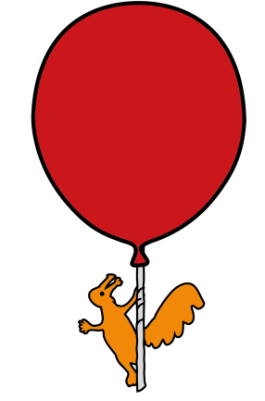


Dental and Oral & Maxillofacial Department

Traumatic Dental Injuries

Information for patients, parents and carers

What is covered in this leaflet?

Dental injuries include any damage to the teeth, lips, gums and tongue.
They can result from sport or road traffic accidents, fights, falls or accidents during play.
This leaflet will look at:
- The most common dental injuries
- Dental splints
- Cleaning teeth following dental injury
- Possible complications
- Follow up and future dental needs following dental trauma
The most common dental injuries include:
- Broken or fractured teeth.
A broken tooth may not require any immediate treatment in the Emergency Department.
It is recommended that you should see your own dentist as soon as possible. It would be useful to have a dental x-ray to check there are no other injuries and you may need the tooth to be smoothed or a have a temporary filling placed to cover it. The type of treatment will depend on the extent of the fractured tooth.
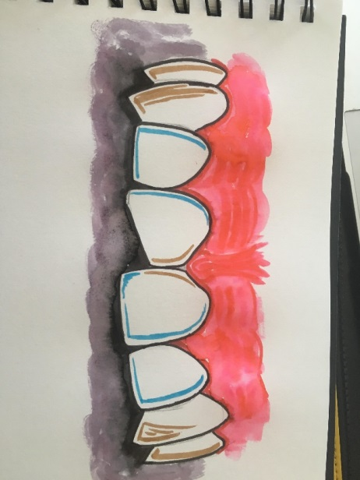
- Displaced teeth.
If a tooth is displaced / pushed from its normal position, it may be repositioned and ‘splinted’ into place. This allows the tooth to heal in the correct position and prevents further movement.
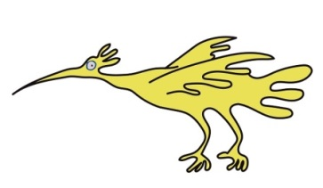

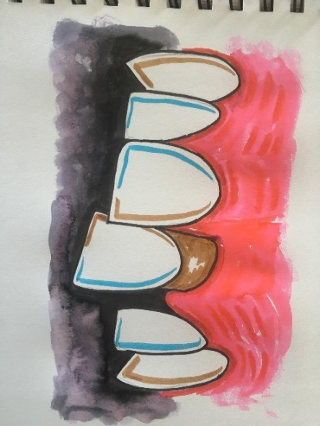

- Avulsed or lost teeth.
An avulsed tooth is one that has come completely out of its socket. If the tooth is an adult tooth the treatment is usually to re-insert it as soon as possible into the socket. A splint is then placed to keep it in the right place and to prevent further movement.

How successful this will be depends on how long the tooth was out of the socket and how well it was looked after whilst it was out. These teeth will need close monitoring by the dentist and often require root canal treatment and long term follow up.

If the tooth is re-inserted, please ensure you check your child’s immunisations are up to date, specifically tetanus.

Baby teeth are not re-inserted. Even so it is important to let your dentist know what has happened so they can monitor the eruption of the adult tooth lying underneath.

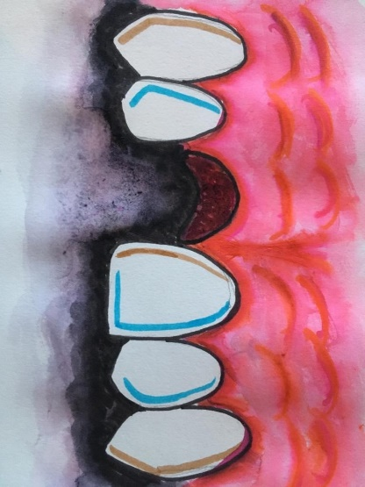

What is a dental splint?
The most common splint is made of a thin wire that attaches the damaged tooth to nearby healthy teeth. Other types of splint can be like a mini-brace with brackets on the teeth.

Splints are placed to hold teeth in the correct position and to prevent the tooth from any further movement. The amount of time the splint is left in place depends on the injury.

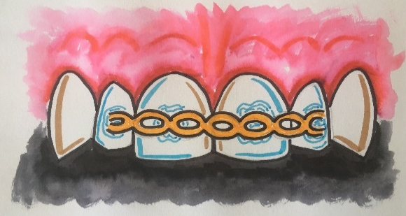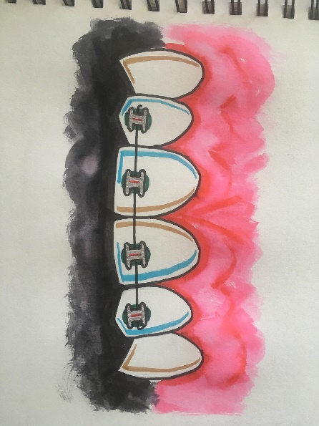

Treatment of soft tissue injuries in the mouth
After you have been examined, any foreign material such as glass or dirt will be removed from the wound. It may be necessary for the wound to be closed with stitches. Stitches inside the mouth usually do not need to be removed since they are often dissolvable. They can, however, take up to 5 weeks to disappear. Not all cuts in the mouth require stitching, the soft tissue in the mouth can heal well by itself if the cut is small.

Importance of follow-up with your dentist

It is very important that dental injuries are followed up regularly by a dentist. Many tooth injuries need further treatment and your dentist may chose to refer you to a paediatric specialist for further care. You will need to book an appointment with your dentist as soon as possible after the injury.

Can I clean my teeth?
Where adult teeth have been damaged, a mouthwash is often the most gentle way to keep the mouth clean and reduces the risk of complications such as infection.

We usually recommend that you rinse your mouth after meals, it you injured an adult tooth, you could use a mouthwash that can be bought from the pharmacy, called Corsodyl. Alternatively warm salt water (one level teaspoon of salt in one tumbler of warm water) can be used. You could use a soft, small headed / baby toothbrush to very gently clean the teeth, or some gauze or a clean flannel to wipe off accumulating plaque.

The other areas of your mouth can continue to be brushed as normal and once the injured area is healed, you can brush more thoroughly in this area. You may want to speak to your dentist about brushing techniques.

How do I care for my mouth at home?

It is important to avoid eating hard foods on recently traumatised teeth, and teeth that have been splinted. You will need to eat a soft diet to prevent any further trauma to the teeth and to prevent the splint from breaking.
You may need to take regular pain relief, for example Paracetamol and/or Ibuprofen, in the days following your injury. Please follow the instructions on the packet closely or ask your pharmacist or doctor for advice.
There may be some swelling and bruising around the site of injury. This may take up to a week to disappear. Take care when eating, so that you do not bite on any swollen areas.

If you have been prescribed antibiotic medication, make sure that you complete the full course.

To help prevent future injuries, wearing helmets and having mouth guards made for contact sports is advised.

Possible complications
- Bleeding. Some oozing from around the site of trauma is to be expected. Significant bleeding is very unusual and can usually be stopped with pressure. This can be done by biting on a clean rolled up handkerchief or swab for approximately 20 minutes.
- Infection. Increasing discomfort or an unpleasant taste can be a sign of infection. Look out for changes in colour or mobility of the injured teeth, as well as swelling or increasing tenderness on biting on the teeth. This may indicate that the nerve of the tooth has been affected and that an infection may be developing. If you are concerned you should see a dentist for further assessment and advice.

- Damage to permanent successor (adult) tooth. If a baby tooth has been traumatised or becomes infected, the developing adult tooth underneath may become affected. This may lead the adult tooth to have changes in its appearance or shape such as pits or dark marks. It may also grow through the gum slower or not at all. Monitoring by the dentist is advised.

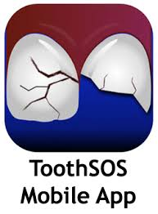



What if we don’t have a denist?

If your child is not registered with a dentist you can find an NHS dentist using the website https://www.nhs.uk/service-search/find-a-dentist. If after contacting several dental surgeries you still cannot find a dentist accepting NHS patients, call NHS England's Customer Contact Centre on 0300 311 2233.
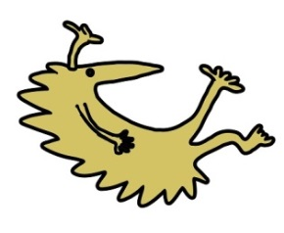
References:
https://www.dentaltrauma.co.uk/Index.aspx
https://www.bspd.co.uk/Resources/BSPD-Guidelines
https://www.sickkids.ca/pdfs/Dentistry/12902-DentalInjuries.pdf
‘ToothSOS’ free mobile app (by International Association of Dental Trauma)

This leaflet only gives general information. You must always discuss the individual treatment of your child with the appropriate member of staff. Do not rely on this leaflet alone for information about your child’s treatment. This information can be made available in other languages and formats if requested.

Alder Hey Children’s NHS Foundation Trust
Alder Hey
Eaton Road
Liverpool
L12 2AP

Tel: 0151 228 4811
www.alderhey.nhs.uk

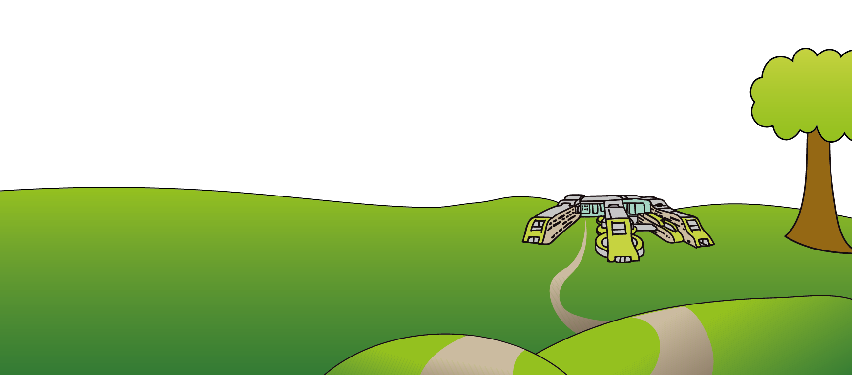
© Alder Hey Review Date: April 2024 PIAG: 271

