- We will ask some questions to help us to understand how things are for you.
- Some of us will write things down whilst you talk, to help us to remember all the things which you say.
- There will be time for us all to talk together, to think about how we may best move forward.

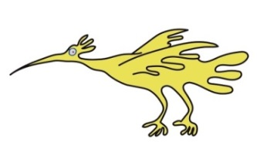

If you have any queries, please feel free to contact the Rheumatology Pathway
Co-ordinator on: 0151 282 4521

This leaflet only gives general information. You must always discuss any individual concerns with the appropriate member of staff.
This information can be made available in other languages and formats if requested.

Alder Hey Children’s NHS Foundation Trust
Alder Hey
Eaton Road
Liverpool
L12 2AP

Tel: 0151 228 4811
www.alderhey.nhs.uk

© Alder Hey
Review Date: May 2024

PIAG: 118

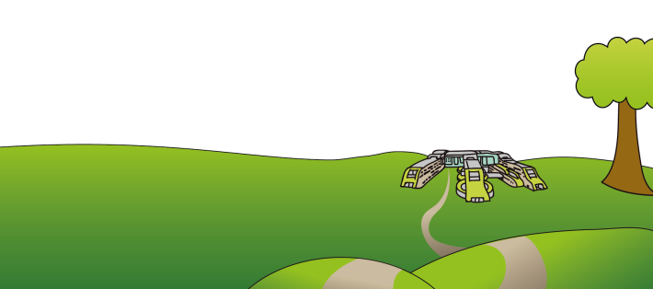



Rheumatology Therapies
Clinic



Information for patients and your family

What is the Rheumatology therapies clinic?
- We are a team of Physiotherapy, Occupational Therapy and Clinical Psychology. We work within the Rheumatology service, and support children and young people with health difficulties, in particular, when pain is part of your life.

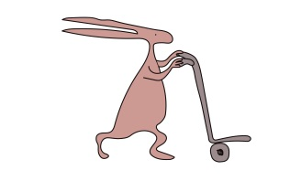
- You have been referred to our clinic because a member of the Rheumatology service felt that the needs which you have may be best assessed by meeting us altogether.

Aims of the clinic

- To discuss with you and your family how your particular problem(s) are currently affecting you, including at home, school and with your friends.

- To think with you about how your needs may best be met and how you may be supported to manage symptoms and feel more in control

- We will ask about things you’ve tried in the past, like medications & strategies

- Some of the team may see you again, or we may redirect you to a more appropriate service

Who may you see at the clinic?
The clinic is made up of the below team members. You will meet some of us during your clinic appointment, but not everyone may always be there.


Clinical Psychologist

Occupational Therapist

Physiotherapist

Why do we work in a multidisciplinary team?
It may sound a bit scary coming to talk to a few people at once, however we have found that this is one of the best ways to work with children and young people.

This is because we may ask similar questions, and it avoids you having to repeat yourselves to lots of people.
Psychology
Helps with:
Emotions
Fears & anxiety about pain
Adjustment to difficulties
Relaxation
Sleeping difficulties

Chronic health difficulties, for example chronic pain, are often influenced by a variety of factors, therefore we use a combination of psychological approaches and physical therapy to improve symptoms.
Having a range of professionals involved initially means that we can provide co-ordinated help and advice for your needs.

What will happen at the clinic appointment?
- You will meet us all at the same time. If you are having a video appointment, we will all appear on your screen.
- Your appointment may last for between 30 to 60 minutes.

Physiotherapy
Helps with:
Movement
Exercise
Motivation
Self-esteem
Goals

Occupational Therapy
Helps with:
Managing the impact of pain on daily life; Personal care, school, leisure & hobbies, sleep. Goal setting

